Teaching, Learning and

Curriculum

Policy

Our Vision Statement

A Place to SMILE

SUCCESS
  - Believe you can succeed,
and be the best you can be.

MUTUAL RESPECT
  - Respect yourself, respect others,
respect your surroundings.

INCLUSION
  - Value differences and overcome barriers.

LIFELONG LEARNING
  - Inspired to learn – at home, at school, for life.

ENRICHMENT
  - Explore, experience, challenge –
within the curriculum and beyond.

This vision, devised by staff and governors, underpins the work of the school and provides the structure for this policy.

Our Learning Values:

At Whiteley Primary School, staff and pupils worked together to identify a set of learning values, representing the skills for learning which we hope all pupils will acquire and develop during their time at our school.

The five values are independence, participation, creativity, perseverance and global thinker. Pupils are given explicit opportunities to develop and understand these values through their everyday learning, and teachers must select at least one per half term to focus on within a unit of cross-curricular work. Values are displayed in classrooms and positive reinforcement is used to raise the profile of the values across the curriculum. Regular reference to the values is made through assemblies and when recognising achievements of pupils.
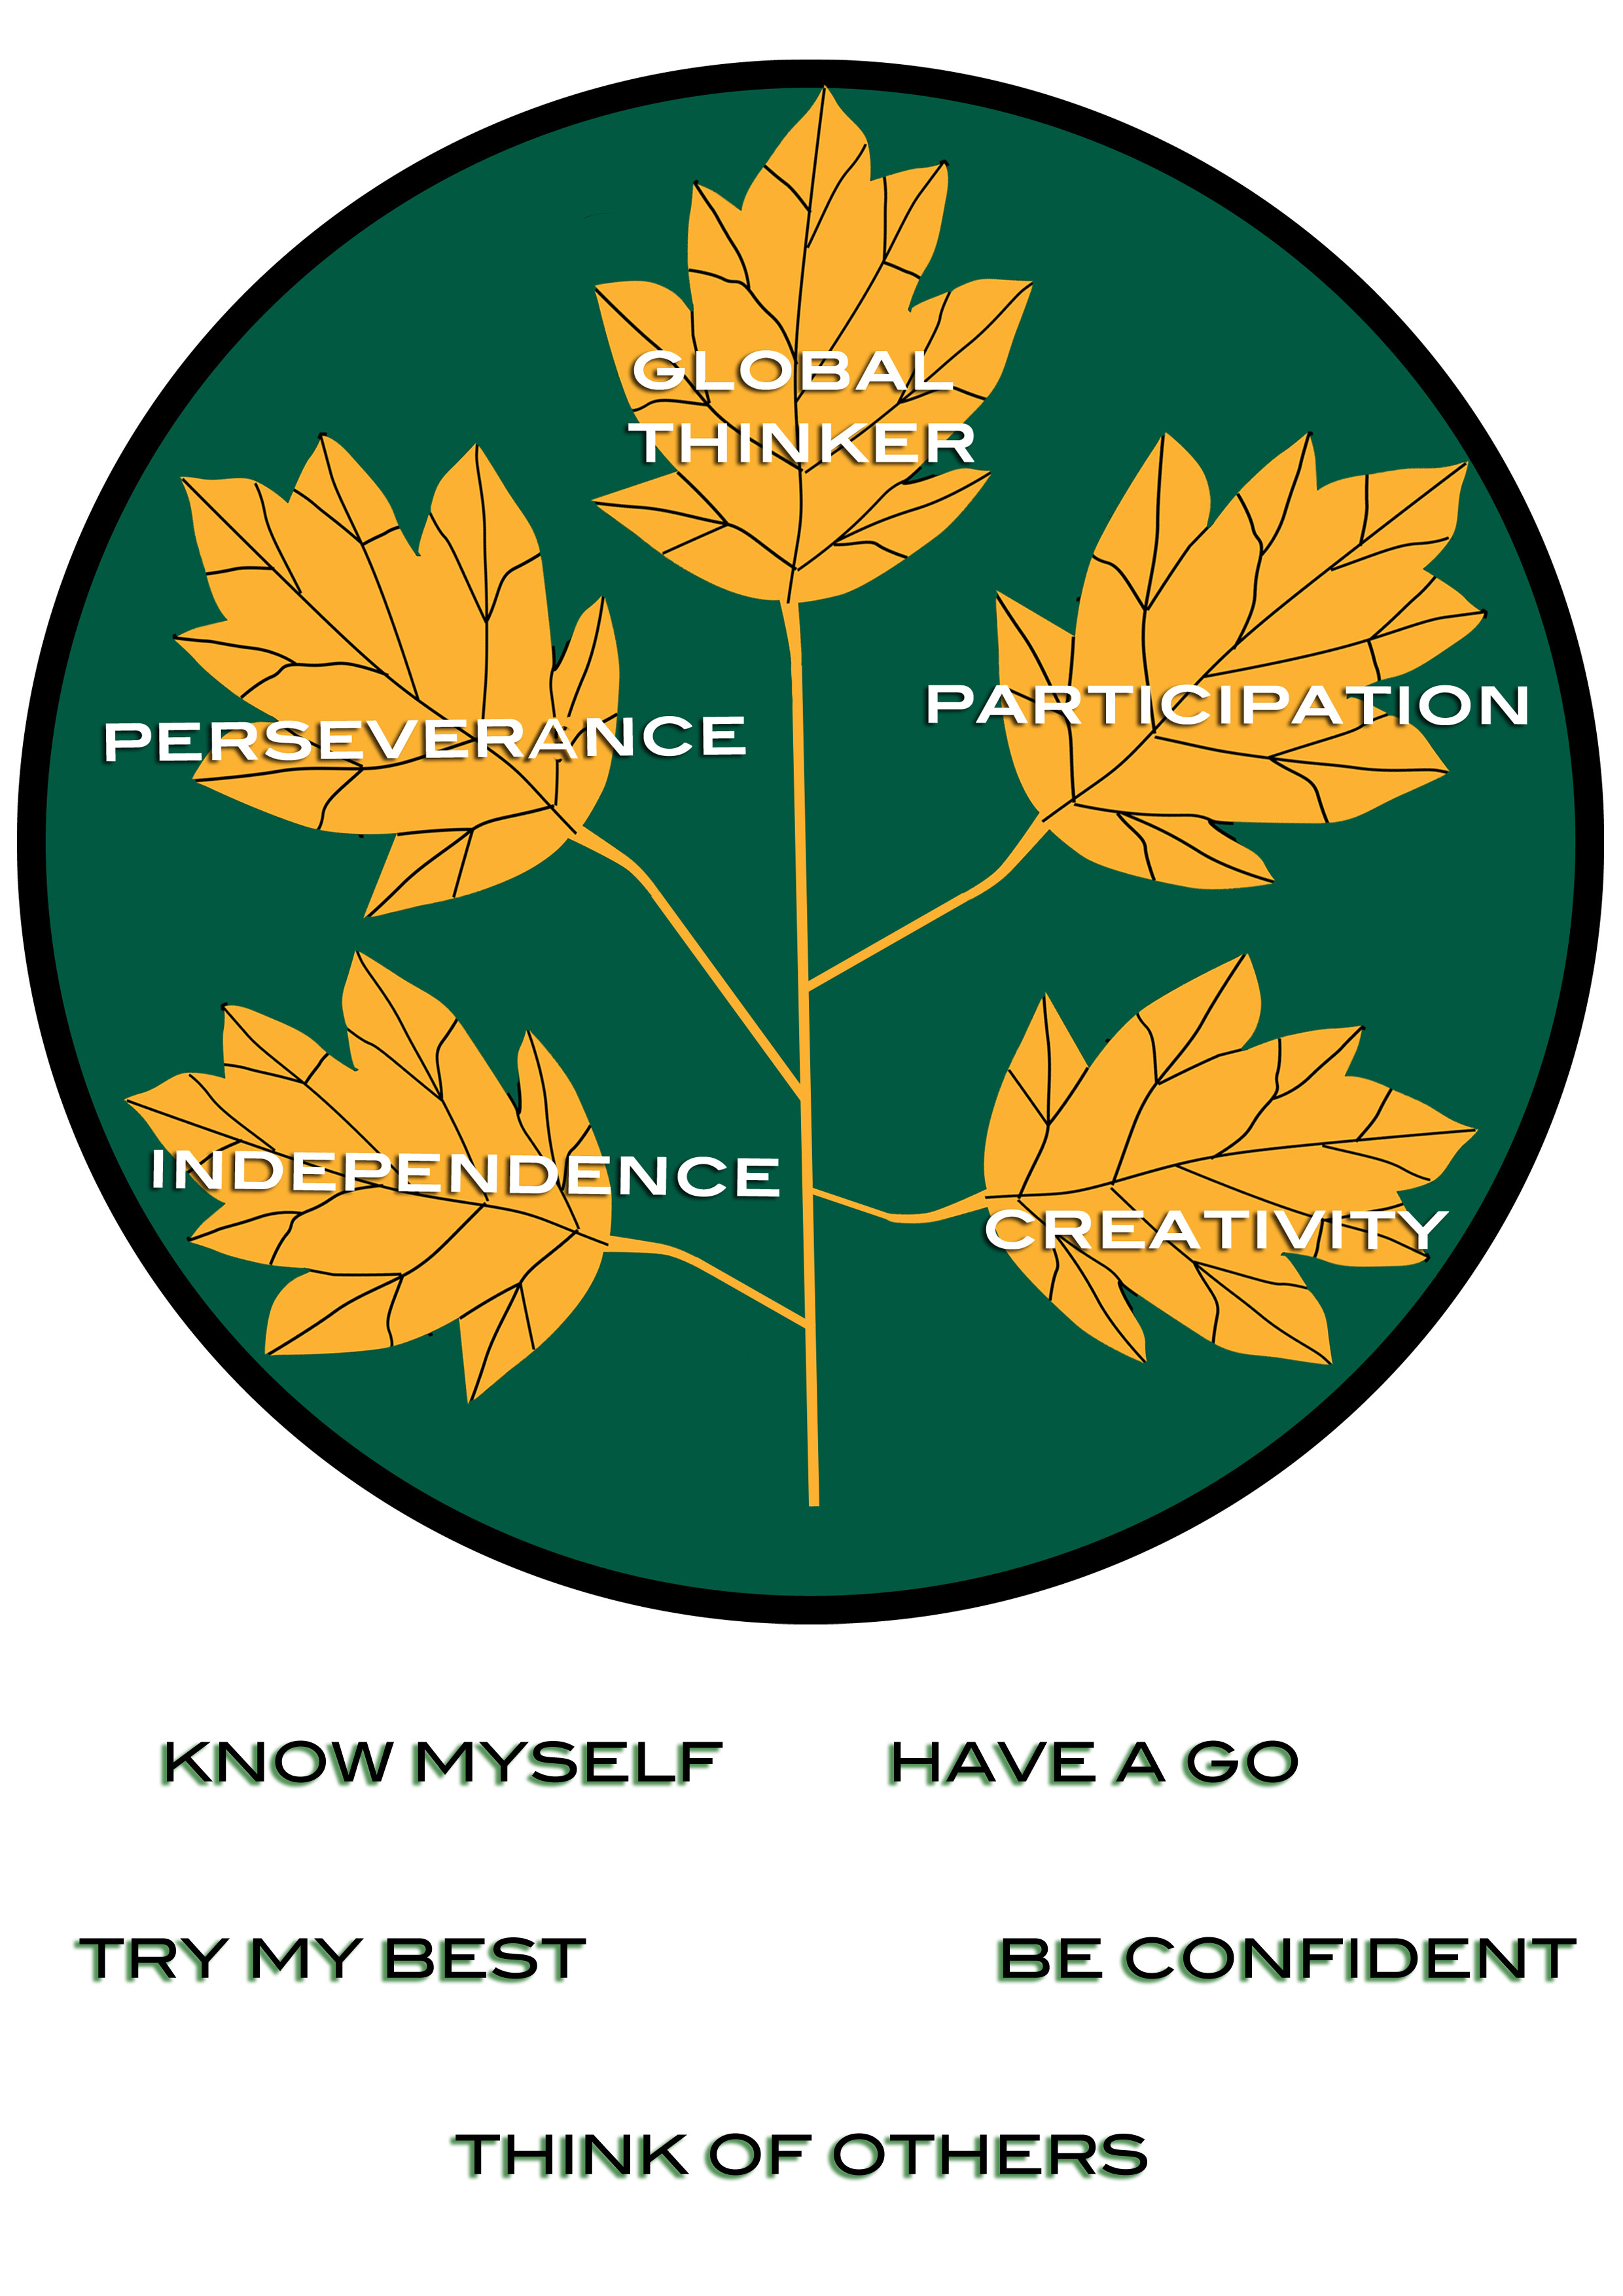

Section 2

SUCCESS - Believe you can succeed, and be the best you can be.

At Whiteley Primary School, it is our aim that all pupils will be successful learners, motivated to achieve the very best they can and with the confidence to believe in themselves. In order to secure this, we must ensure high quality teaching and a supportive environment where learners can flourish and be happy whilst also gaining key knowledge, skills and understanding, readying them for the next stage in their education.

A Curriculum for Success
We believe that pupils are entitled to a broad, balanced and creative curriculum. At Whiteley Primary School, our curriculum is made up of the following:
- Early Years Foundation Stage – in Reception classes, we follow the EYFS curriculum.
- National Curriculum 2014 – we follow the requirements of the new National Curriculum in Y1-Y6, incorporating the aims and objectives into our medium term unit plans. Meaningful links are made through cross-curricular units of work where possible, supplemented by discrete subject teaching to ensure appropriate coverage.
- Hampshire RE Syllabus ‘Living Difference’.
- PSHE – this is non-statutory but an aspect of the curriculum which we consider of high importance.
- Our school curriculum – aspects of learning which we consider important for our pupils or which are of pertinence for our pupils or locality. This includes learning about Rights, Respect and Responsibilities (RRR).
- The ‘hidden’ curriculum – what the children learn from.the way they are treated and expected to behave in school which is reflected in the ethos of our school.

Planning for Success
The Whole School Long Term Curriculum Plan provides the overview for the units of work to be taught in each year group and enables subject leaders to ensure appropriate coverage of objectives. Each unit of work contains the National Curriculum references for the subjects to be covered. Links with other subject areas are made if they are relevant to the year group.

Year groups produce medium term plans for each unit of work, specifying the national curriculum objectives for each subject covered through the unit and the learning value focus. Medium term plans specify English links to the unit of work and may also include maths links. Year teams identify a ‘hook’ as a way of introducing the unit of work, the intended outcome and time scales for the unit. They also specify home learning links. It is the responsibility of the year team to ensure that the unit of work is pertinent to the cohort they are teaching. Pre-planning sessions should take place where children are asked for their ideas about what they know already and what they wish to learn from the unit. These ideas are a crucial part of the planning process.

From this medium term plan, short term plans are created. Teaching approaches should be discussed as a team so that a range of approaches may be offered to the children, reflecting the talents and interests of the teachers as well as the requirements of the curriculum and the needs of the class. It is not necessary for all teachers in a year group to use the same teaching approach for all objectives. However, key opportunities for learning will be identified which all children must experience – these may be linked to assessment foci.

In maths and English in particular, teachers are encouraged to be flexible in their planning to ensure that lessons can be adapted each day to reflect the needs of the class based on the on-going assessment for learning that takes place.

Curriculum planning is supported by the use of a range of resources to ensure appropriate challenge and progression, provide a variety of resources, and to support the development of teacher subject knowledge. Resources include
- Rising Stars maths planning
- Hampshire History Team units
- Letters and Sounds (phonics)
- No-Nonsense Spelling
- Music Express

Pedagogy for Success
Pedagogy is the art, craft and science of teaching. It is the variety of strategies which a teacher will employ to ensure equality of access and effective matching of tasks to needs. Below are a range of strategies which may be employed across a unit of work and within a lesson:
- Teacher Modelling
- Interactive teaching
- Discussion and questioning (open and closed as appropriate)
- One to one teaching
- Collaborative learning in pairs or groups
- Independent learning
- Teacher observation
- Child initiated tasks
- Using Blooms taxonomy to identify higher order thinking skills
- Previewing and reviewing work
- Following own line of enquiry
- Use of Philosophy for Children (P4C) activities to develop discussion and thinking
- Conferencing
- Listening
- Brainstorming
- Providing opportunities for reflection by pupils
- Providing opportunities for repetition / reinforcement
- Providing encouragement, positive reinforcement and praise
- Making judgements and responding to individual need
- Intervening in the learning process, as appropriate, in order to encourage development

Whilst there are a range of teaching methods which may be employed, these need to be chosen carefully to match the needs of pupils and the context. Teachers must be flexible in their approach to classroom organisation, management and delivery in order to effectively meet the needs of all. At Whiteley Primary School, we place high importance on the involvement of pupils in their learning and stress the importance of active participation and hands-on learning within the classroom.

Feedback for Success
In order for pupils to experience success in their work, they need to understand what they are learning, how they will know they have succeeded and what their next steps for learning are. This is communicated to pupils in a number of ways:
- Sharing of learning objectives during a lesson and revisited throughout
- Pupil involvement in defining the learning objectives
- Sharing of success criteria
- Pupil involvement in defining the success criteria and self-evaluation against these criteria
- Target setting in maths and English – whole class, group or individual
- Genre checklists for writing
- Marking against the learning objective
- Verbal and written feedback
Further information can be found in the school’s marking policy (Appendix A)

MUTUAL RESPECT – Respect yourself, respect others, respect your surroundings

Whiteley Primary School is a ‘Rights Respecting School’. Pupils are explicitly taught children’s rights as laid out in the UN Convention on the Rights of the Child, and also explore the responsibilities that are implied by these rights. In this way, pupils are empowered by knowing that they have rights, but develop an understanding of what it means to respect the rights of others. Rights, Respect and Responsibilities are taught explicitly (through assemblies, circle time, displays, focussed lessons) and implicitly across the curriculum (through the use of rights-respecting language and approach modelled by adults).

INCLUSION – Value Differences and Overcome Barriers

It is our aim that all pupils should enjoy their learning and be able to experience success. It is the responsibility of all teachers to ensure pupils make progress from their own starting points, offering appropriate challenge and working to ‘narrow the gap’ of any pupils who are falling behind.

In the course of their daily work, the staff will contribute to the development of an inclusive and secure environment through:
- Providing a calm, quiet and effective working environment at all times in which each child can achieve his or her potential
- Providing a welcoming environment in which courtesy, kindness and respect are fostered.
- Providing positive role models.
- Providing a fair and disciplined environment in line with the school’s behaviour policy.
- Valuing the input children have into the development of the school (KS2 Young Governors, KS1 Working Parties, RRR class ambassadors, House Captains etc).
- Involving pupils in decision-making at a class, year group and whole school level (e.g. interviews for new staff, choosing charities etc.)
- Providing opportunities to ask children for their input before a unit of work (pre-planning), establishing what they already know and what they would like to know more about, before feeding this into the planning for the unit of work.
- Providing opportunities for pupils to give feedback to governors in order to contribute to school self-evaluation and improvement.

Provision and support for any vulnerable pupils are overseen by a dedicated inclusion manager (including those with SEND, looked after children, pupil premium groups, young carers etc.) and there is a link inclusion governor to ensure that the outcomes of this work are reported to the Full Governing Body. Developing high quality teaching and learning, which meets the needs of all learners, is a priority for the school as reflected in the school’s continuing professional development (CPD) programme. Our SEND report/policy provides more detailed information about our provision for pupils with Special Educational Needs or Disabilities.

LIFELONG LEARNING – Inspired to learn – at school, at home, for life.

At Whiteley Primary School, we believe we have a responsibility to ensure that pupils not only experience success whilst they are with us, but that firm foundations are laid for them to experience success beyond our school. The development of independent learning across the school is a vital part of this, providing the opportunities for pupils to follow their own interests, take ownership for their learning and make choices about how they will record their learning.

In Year R, children have regular, extended opportunities to carry out child–initiated learning – we call this ‘Play, Discover, Learn’ time. Adults in the classroom observe and engage with pupils during this time, and look for ways in which to extend their learning by enhancing the areas inside and outside the classroom, as well as planning adult-directed tasks to support their development.

In Year 1, pupils continue to have daily independent learning opportunities. There is a greater focus on the learning values in Y1, and children are given ideas for ways in which they can extend the learning around their class unit of work. In Year 2, pupils have ‘Discovery Time’ opportunities during the week where they can choose aspects of their class topic to explore further.

In KS2, pupils may be given ‘Whiteley Learner Time’ where they can make choices about their learning within their class topic. Pupils are also provided with opportunities for independence across the curriculum – for example, making choices regarding the work they complete in maths (Back2Basics, Consolidate and Challenge); selecting the writing outcome when writing for specific purpose in English; or making choices regarding how to record their learning in their topic work.

We believe that if pupils enjoy their learning at school, they will be motivated to continue their learning at home. Across the school, parents/carers are kept informed of units of work and given practical ideas for ways in which to involve their child in learning activities at home. A rich curriculum and exciting learning opportunities in school inspire pupils to continue their learning beyond the classroom and we value the ideas and experiences that pupils bring from home.

In order to inspire and motivate learners, we believe that our staff should be strong role models as learners; they should show pupils that learning is a lifelong process and be open to new ideas and experiences. We invest well in staff CPD, and encourage Enquiry-based learning amongst teaching staff in order for them to continue to develop as teachers, to be familiar with research, to explore what works well and why in their own classrooms, and to share with others good practice.

ENRICHMENT – Explore, experience, challenge
– within the curriculum and beyond

Throughout the school, we look for opportunities to enhance the curriculum in the following ways:

- Trips – these may be used to provide a ‘hook’ for a unit, enable pupils to demonstrate their knowledge and understanding during a unit or provide hands-on learning to support a unit of work.
- Visitors – we aim to draw on parents, the wider community and links beyond the school in order to provide specific expertise (e.g. dance workshops, sports coaching), experience of cultural activities (e.g. Bournemouth Symphony Orchestra) and role models from the world of work (e.g. fire service, dentist, bank manager etc).
- Extra-curricular activities – a range of activities are provided from Y1-Y6 which enhance the curriculum on offer to pupils, developing skills which can be applied through their classwork and beyond the school (e.g. sport clubs, music, dance, art, chess, science etc)
- Use of the school grounds – we are fortunate to have such an excellent resource on our doorstep, and regularly make use of the school grounds across the curriculum to provide hands-on learning opportunities and inspiration for creative work (e.g. pond-dipping, natural sculptures, mini-beast hunt etc.)
- Enrichment groups – groups of pupils may be targeted for enrichment activities to deepen their learning, challenge their thinking, or provide opportunities not normally available within the curriculum. For example, maths enrichment groups provide opportunities for those with a secure understanding of maths to broaden their application of skills; architecture workshops allow pupils to develop and apply problem solving skills; attending the Primary prom concerts provides inspiration for musicians at the school and participation in Sport festivals and events enables pupils with particular talents to compete against other schools.

Date policy agreed: September 2015

Review date: Autumn term 2018

APPENDIX A
Marking Policy

