Day 1

Teach
Watch the videos on this website and read through the information:
https://www.bbc.co.uk/bitesize/topics/zwwp8mn/articles/zqk37p3
Or, read this information below:
Subordinating conjunctions
A conjunction is a word, or words, used to connect two clauses together. Words such as: 'although', 'because' or 'when' .
A subordinating clause is a part of a sentence that adds additional information to the main clause. A subordinating conjunction is simply the word/words that is used to join a subordinating clause to another clause or sentence.
"He was annoyed, the train had stopped."
"He was annoyed because the train had stopped."
By adding 'because' we are linking the subordinating clause "the train had stopped" with the main clause "He was annoyed".

Practice

Activity 1 & 2

Activities 1 and 2 can be completed on the website attached at the top.

Activity 3

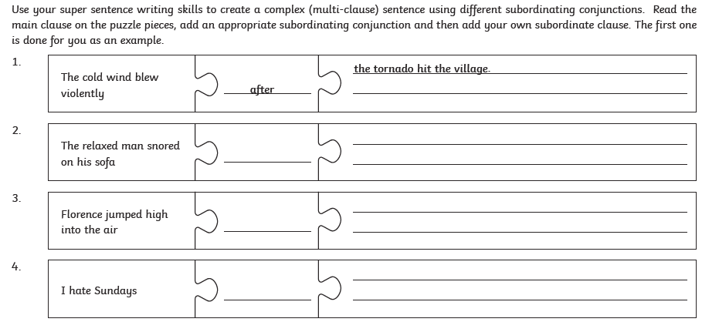

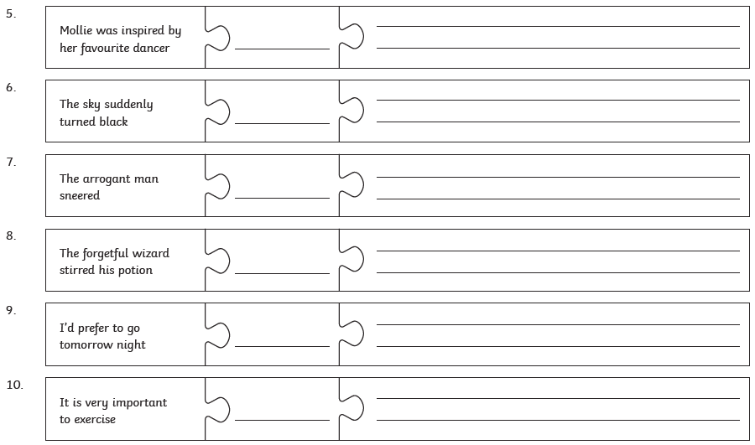

Day 2

Teach
Work through the information on this website, watching the videos:
https://www.bbc.co.uk/bitesize/topics/zvwwxnb/articles/zc773k7
Commas in sentences
Adding a comma can change the meaning of a sentence.
- Let's eat Albert. = We're going to eat Albert.
- Let's eat, Albert. = We're eating with Albert.
In a long sentence, you can use commas to separate out extra information and make the sentence easier to read. These commas do the same job as brackets but look a lot neater in your writing.
- Albert (the alien with blue spots) is from the planet Zoink.
- Albert, the alien with blue spots, is from the planet Zoink.
A clause is the building block for a sentence. Commas can be used to break up sentences that have more than one clause and make them easier to read.
- When Albert saw the food, his tummy started to rumble.
- Albert got used to the blue spots, but then they started itching.
Both these sentences have a subordinate clause. Subordinate clauses do not make sense on their own.
These clauses need the main part of the sentence to make sense, so they are connected with a comma.
The comma shows that they are closely connected to the main part of the sentence.
If the clauses make sense on their own, you don’t need to use a comma. For example:
- Albert was excited about eating. He wanted to use a knife and fork.

Practice

Activity 1 & 2

Activities 1 and 2 can be completed on the website attached at the top.

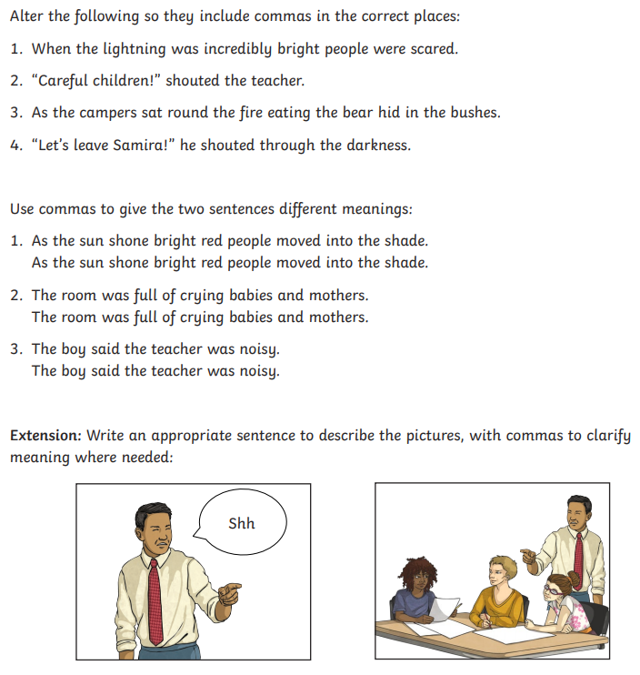
Activity 3

